
QUALITY ALERT

Customer: United Date: April 02, 2022
Die: 15138 Colour: ALL COLOURS
Type of Complaint: United REJECTED

Q.A # Q.I.R # CUSTOMER NCR #

Description: United REJECTED – Pieces are COLLAPSE causing run gap too close.
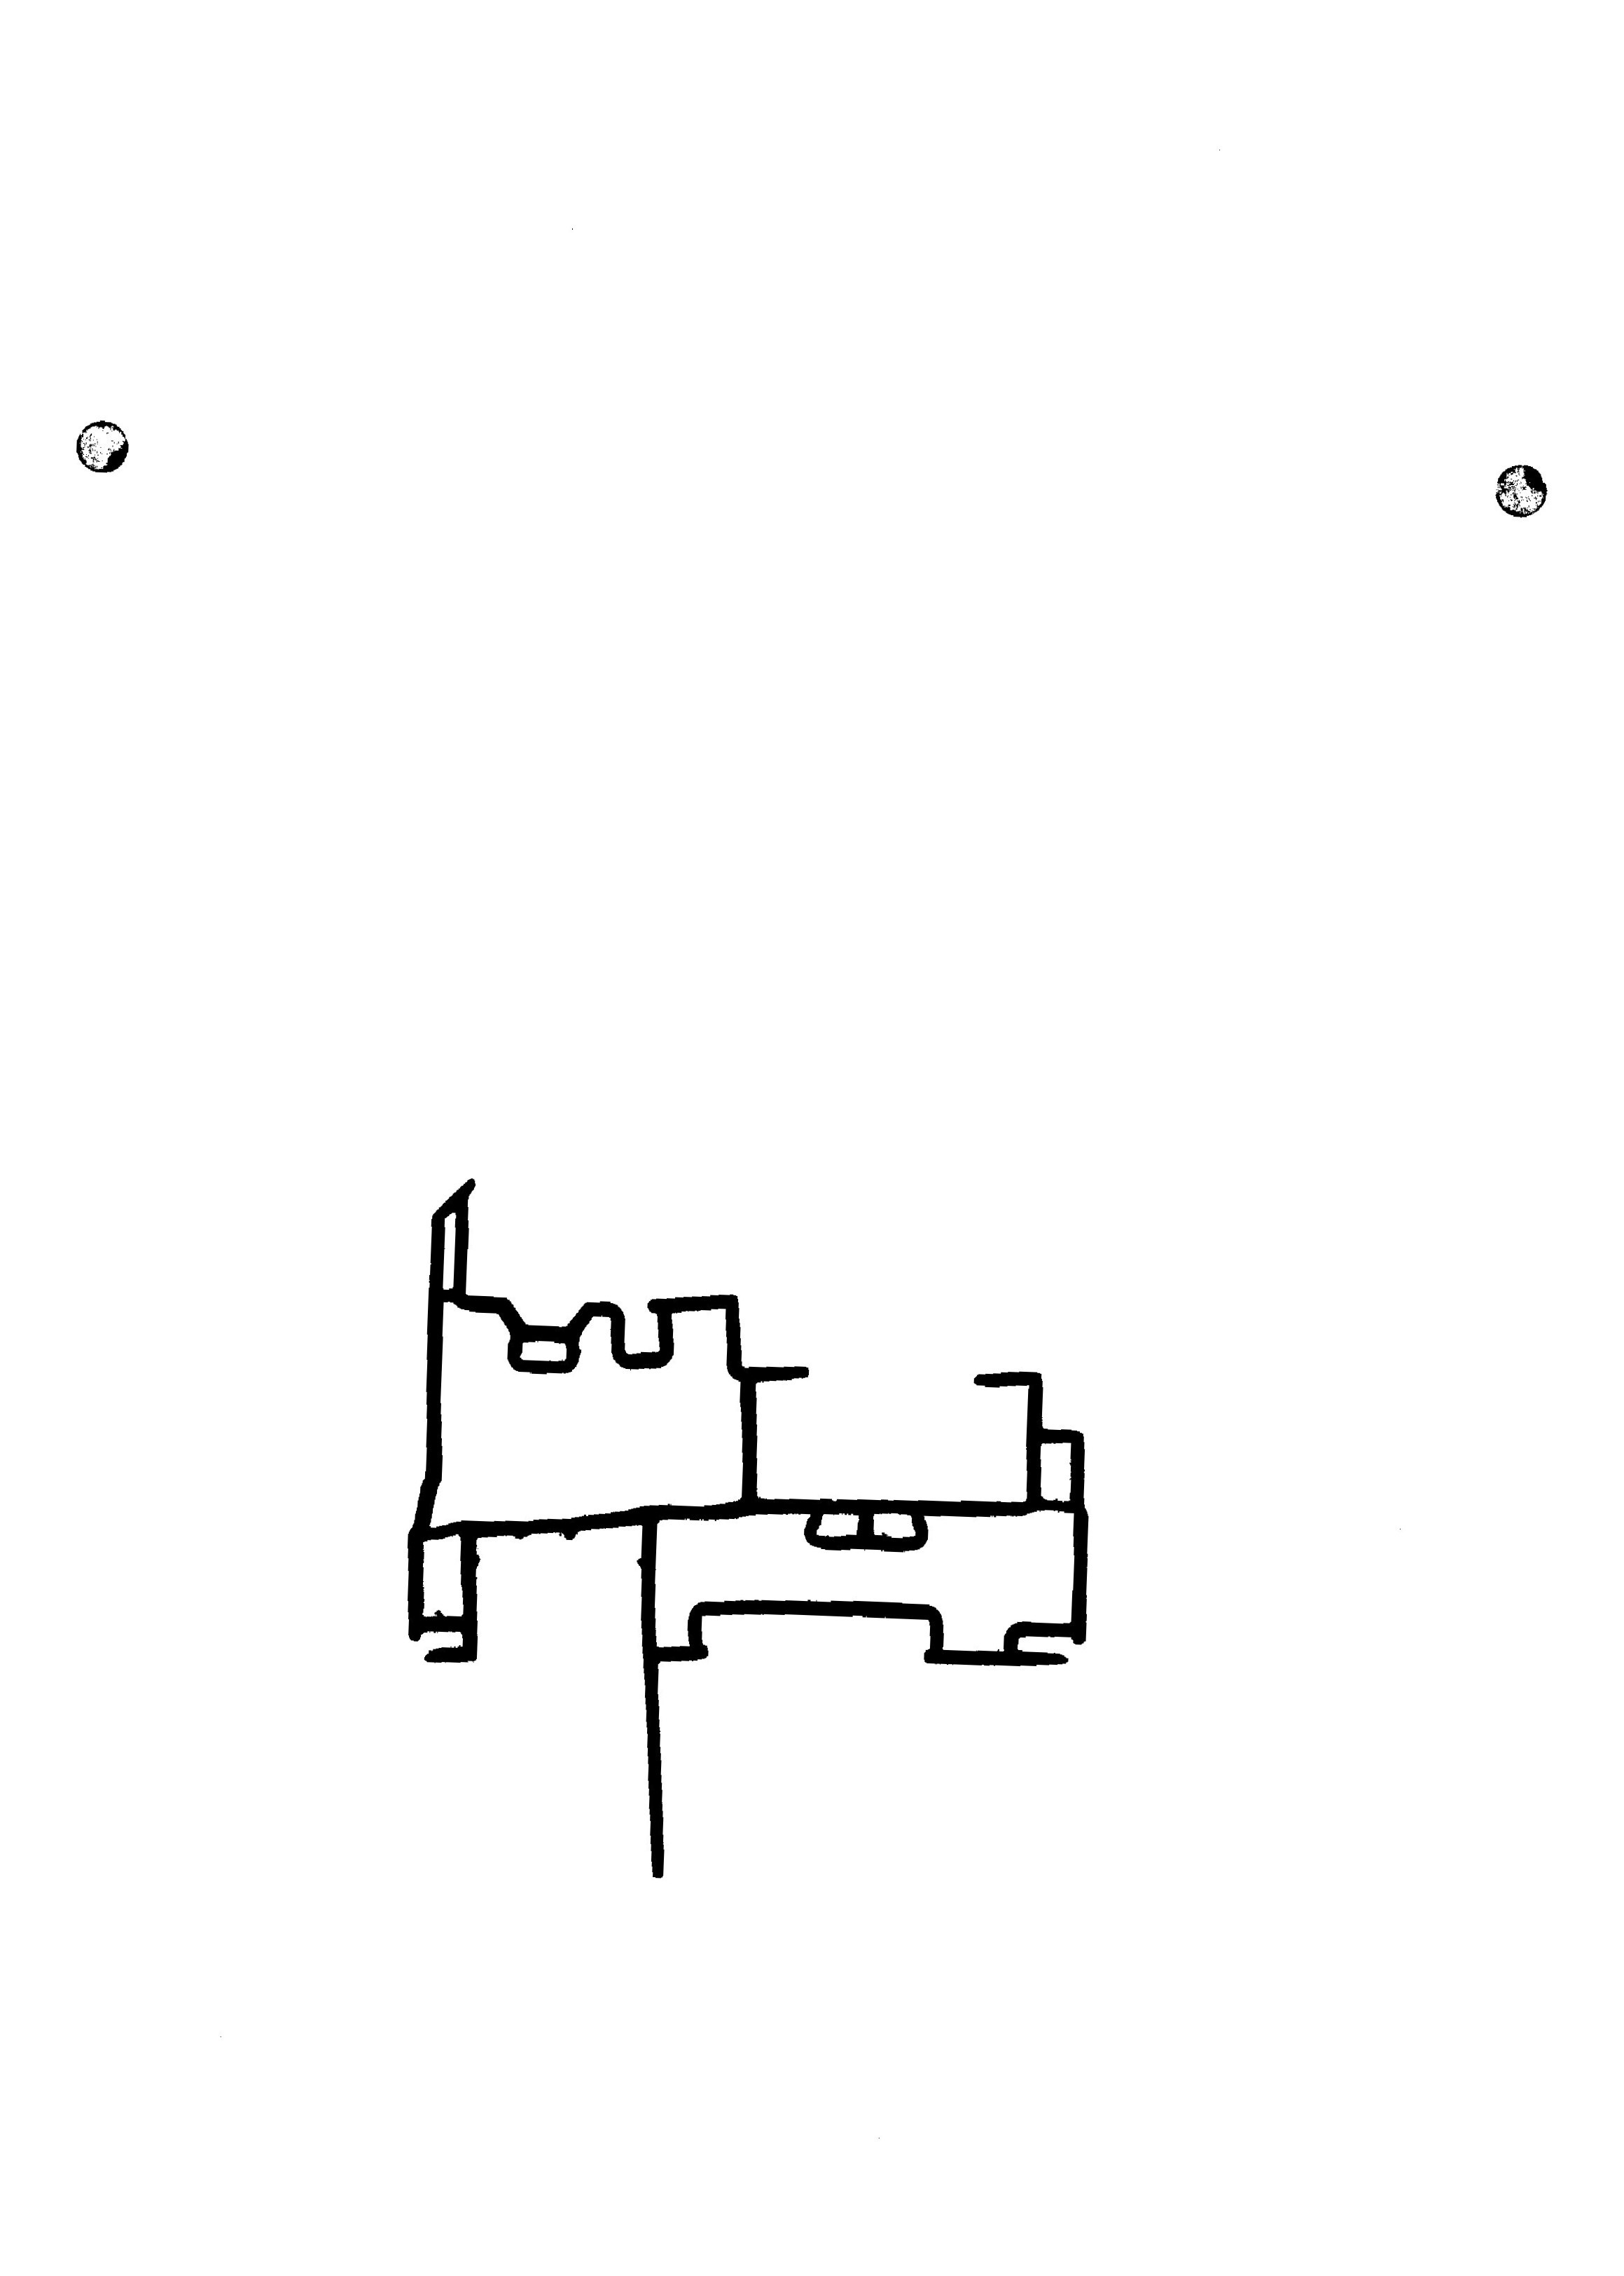
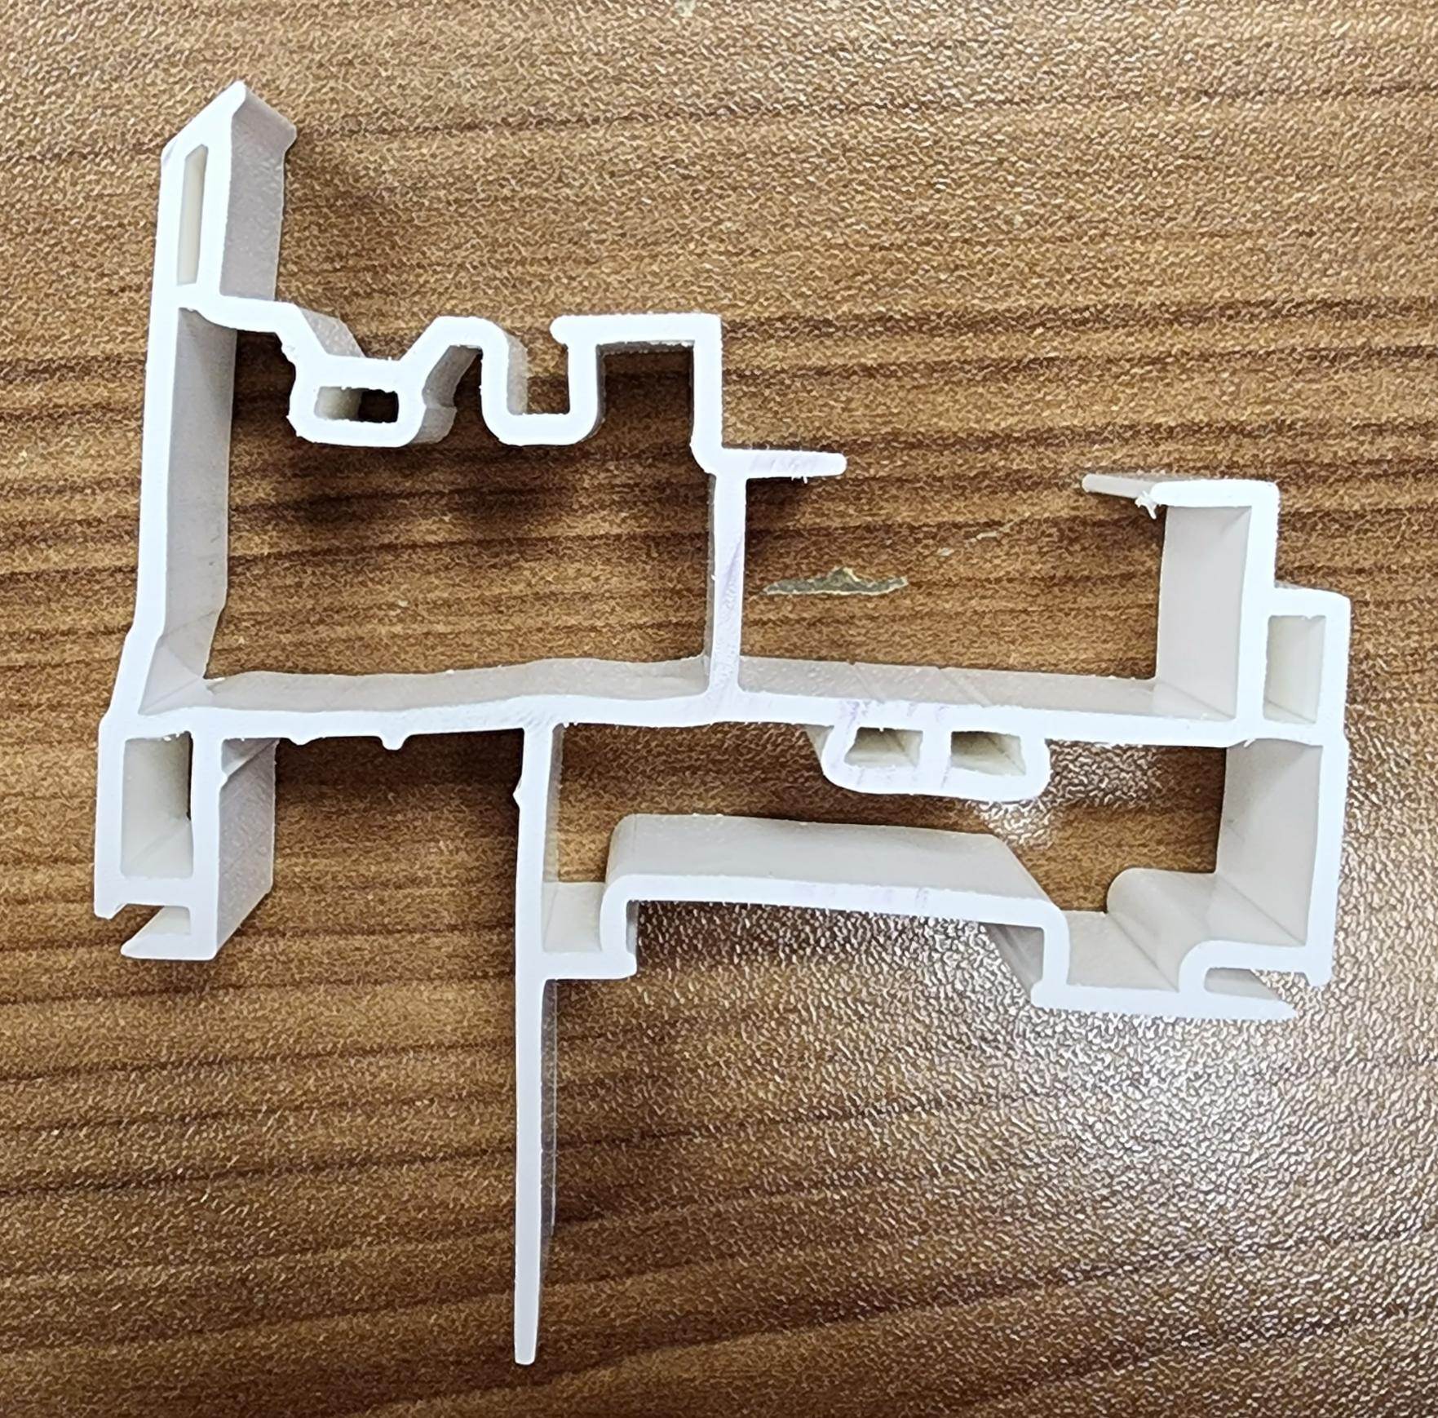

V

PLEASE MAKE SURE MATERIAL ARE GOOD SHAPE
AND
THE RUN GAP IS IN TOLERANCES

BY SIGNING BELOW, YOU ACKNOWLEDGE THE PROBLEM ABOVE AND AGREE TO MONITOR THIS ISSUE IN FUTURE PRODUCTION RUNS.
DAY SHIFT |  | AFTERNOON SHIFT |  | NIGHT SHIFT
NAME | SIGNATURE | NAME | SIGNATURE | NAME | SIGNATURE

